**Introduction**

The Depth-AI camera modules and connectors are a deciding factor in which product makes sense for you. Whether you are developing your own product or deciding which available board to purchase, which cameras that device contains offers tradeoff in flexibility, capabilities, quality, and cost. Before going through options, I will explain a bit more on these modules. To get straight to the options, go to the end of the doc.

Unfortunately, these cameras (and sometimes their connectors) can be the most difficult hardware in a design to procure. The DepthAI team is working hard with Arducam to make more camera options widely available in any quantity (coming soon!). The FFC designs are being modified to match Arducam’s 22 pin interface (which also matches the RPi 22 pin interface) and so are several camera modules. These changes will make life easier for makers and greatly reduce this problem of buying compatible CCMs.

**Background and Sourcing**

Compact Camera Modules (CCMs) as shown in the picture below, are board mounting camera modules that contain a sensor. Making each camera (or really the sensor inside) interface with the Myriad X through the SoM is the value that DepthAI provides you. By using the camera modules/sensors which they have already developed the software stack for, you save yourself 90% of the time involved in making an embedded computer vision device.

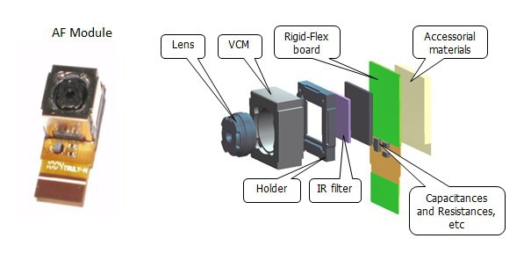

*Figure 1: CCM diagram. Each component of the CCM is made by someone other than the camera manufacturer and thus multiple companies often have identical modules. The important part is what sensor is inside the camera, more on that later.*

These CCMs are most used in extremely high-volume consumer electronics and thus can be hard to get in low volume. Many cameras only have one compatible board connector. Others have a couple, but I will do my best to go through each available camera type, it’s uses and associated connectors at the end of this document.

Thus, for prototyping purposes, some camera modules have been stocked for low quantity sales by Luxonis. If you plan on moving your product into mid-volume production make sure you have a plan for sourcing. If you reach out to the Luxonis team they will be happy to help you source however they can. Luckily for the open-source community, Luxonis is working with a company to bring CCMs to the consumer market permanently and improve upon the proprietary mess that is the camera industry. While the below may look like a lot of manufacturers, many of these will be unlikely to take a call from you without an order of 10,000 or more.

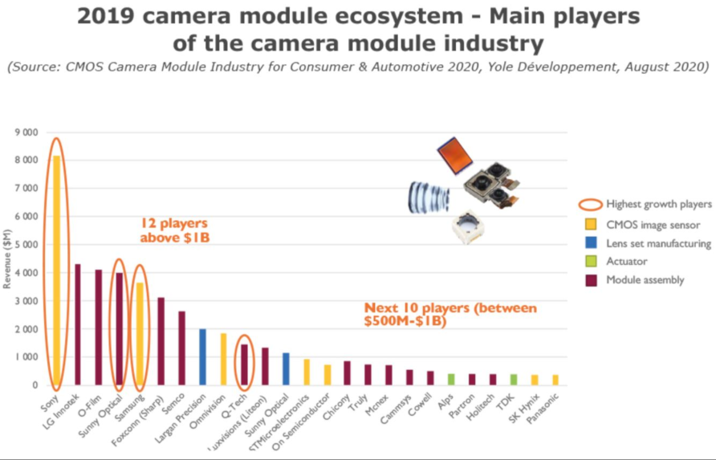

|  |  |  |  |  |  |
| --- | --- | --- | --- | --- | --- |
| Camera | Ref. Designs | Sensor | Connector/Source | Cam Type/Link | Specs: |
| [Sunny Optical AN01V32](https://shop.luxonis.com/products/ov9282-ccm-for-depthai-sunny-an01v32-0jg?pr_prod_strat=copurchase&pr_rec_pid=4706859089986&pr_ref_pid=4706857844802&pr_seq=uniform) | BW1098OBC-USBC | OV9282 | ACON BBR43-24KB533 (can help source) | Fisheye/ Stereo Cameras 1080p |  |
| [Sunny Optical A12N02A](https://shop.luxonis.com/products/4k-imx378-ccm-for-depthai-sunny-a12n02a?pr_prod_strat=copurchase&pr_rec_pid=4706857844802&pr_ref_pid=4706859089986&pr_seq=uniform) | BW1098OBC-USBC | IMX378 | 24-5804-030-000-829 (digi-key) | RGB 4k 60 Hz |  |
| Arducam coming SOON |  | OV9282 | 22 pin FFC Arducam/RPi |  | 155 HFOV (166 DFOV) |
|  |  |  |  |  |  |
|  |  |  |  |  |  |